
TMP UNIVERSAL JOURNAL OF LAW, BUSINESS, AND MANAGEMENT
VOLUME 1 │ISSUE 3│YEAR 2025│JUL – SEP 2025

VOLUME 1 │ISSUE 2│YEAR 2025│APR – JUN 2025
RECEIVED DATE
ACCEPTED DATE
PUBLISHED DATE
09/04/2025
24/05/2025
10/06/2025
Available online: www.ujlbm.twistingmemoirs.com

Article Type: Research Paper
MARKET ANALYSIS OF CONSUMER SATISFACTION AND EXPECTATIONS REGARDING SUZUKI ACCESS 125

¹ Bhavna Mali*

¹ Department of MBA, Vikram University, Ujjain (MP)
Corresponding Author: Bhavna Mali, Email: bhavna.m2376vu@gmail.com

ABSTRACT
Consumer expectations play a crucial role in determining the success of any product in the competitive automobile industry. This study aims to analyze the expectations and satisfaction levels of consumers regarding the Suzuki Access 125 scooter. The research focuses on understanding the factors that influence customer preferences, purchasing decisions, and overall perception of the product. A survey-based research methodology was adopted, and primary data were collected through a structured questionnaire administered to existing and potential customers. The study examined various aspects such as product quality, value for money, design, performance, mileage, after-sales service, and brand image. The findings reveal that a majority of consumers prefer Suzuki Access 125 due to its stylish design, comfortable riding experience, reliability, and brand reputation. Customers also expect better value for money, improved quality, and enhanced service support from the company. The analysis indicates that young consumers form a significant segment of the customer base, highlighting the product’s popularity among modern riders. Overall, the study concludes that Suzuki Access 125 has successfully met many consumer expectations and achieved a favorable position in the market. Continuous product improvement, customer-focused services, and innovation can further strengthen customer satisfaction and brand loyalty, enabling Suzuki to maintain its competitive advantage in the growing two-wheeler market.
Keywords: Employee Satisfaction, Organizational Performance, Workplace Environment, Employee Motivation.
INTRODUCTION
Microfinance institutions (MFIs) are financial companies that provide small loans to people who do not have any access to banking facilities. The definition of “small loans” varies between countries. In India, all loans theater below Rs.1 lakh can be considered as microloans.
Microfinance—also called microcredit—is a way to provide small business owners and entrepreneurs access to capital. Often these small and individual businesses don’t have access to traditional financial resources from major institutions. This means it is harder to access loans, insurance, and investments that will help grow their business. Essentially, microfinance is providing loans, credit, access to savings account—even insurance policies and money transfers—to the small business owner and entrepreneur. There are many such enterprises in the developing world. How Microfinancing Works Microfinance, pioneered by the Nobel Prize winner Muhammad Yunus, helps the financially marginalized by providing them with the necessary capital to start a business and work toward financial independence. These loans are significant because they are given even though the borrower has no collateral. However, the interest rates for these microloans are often very high due to the risk of default. The term microfinance encompasses microloans, micro-savings, and microinsurance. Microfinance institutions provide small loans and other resources to businessowners and entrepreneurs to help them get their businesses off the ground. Many of the recipients are in developing countries and could otherwise not obtain a traditional loan. Micro-savings accounts are also under the microfinance umbrella. They allow entrepreneurs to have a savings account with no minimum balance. And, microinsurance provides these borrowers with insurance at a lower rate and with lesser premiums.

Why Is It Important?

Microfinance is important because it provides resources and access to capital to the financially underserved, such as those who are unable to get checking accounts, lines of credit, or loans from traditional banks.
Without microfinance, these groups may have to resort to using risky loans or payday advances with extremely high interest rates or even borrow money from family and friends. Microfinance helps them invest in their businesses and, as a result, invest in themselves. Employee satisfaction is considered one of the most important determinants of organizational effectiveness and productivity. According to Herzberg's Two-Factor Theory, job satisfaction is influenced by both motivational and hygiene factors, whereas Maslow's Hierarchy of Needs emphasizes the role of fulfilling employees' physiological, social, and self-esteem needs in improving workplace performance. Previous studies have demonstrated that factors such as supervisor support, teamwork, communication, trust, and recognition significantly influence employee satisfaction and organizational commitment. Therefore, the present study aims to evaluate the satisfaction level of employees at Jain Bandhu and identify the organizational factors contributing to employee motivation and workplace effectiveness.

RESEARCH METHODOLOGY

The data needed for the study is collected from the employee, through questionnaire.

Research design
The study was based on survey method. The aim of the study is to Find the“employee satisfaction level”.

Sampling
The study was conducted among 31 employees working at Jain Bandhu, Mandsaur, Madhya Pradesh. Although the sample size is relatively small, it was considered appropriate due to limited accessibility and availability of respondents during the survey period. The respondents represented different categories of employees, thereby providing adequate information regarding employee satisfaction and organizational practices.

Sampling design
Sampling design refers to the procedure adopted for selecting respondents from the target population. In the present study, a simple random sampling technique was employed to minimize sampling bias and ensure equal opportunity for participation among employees.

Descriptive Research design
Descriptive research design was adopted for the present study because it facilitates systematic collection and analysis of information relating to employee satisfaction. The design enables the researcher to describe employee perceptions regarding teamwork, supervisor support, trust, feedback mechanisms, and job challenges.

Data Collection Method
The present study is based on both primary and secondary data. Primary data were collected through a structured questionnaire administered personally to employees of Jain Bandhu. Secondary data were obtained from books, journals, company reports, and published literature related to employee satisfaction and organizational behavior.

Instrument used: The questionnaire consisted of structured items relating to work experience, team spirit, supervisor support, feedback mechanisms, trust, and job challenges. Content validity of the instrument was ensured through expert review and necessary modifications. Reliability of the questionnaire can be assessed using Cronbach's alpha coefficient, and a value greater than 0.70 indicates acceptable internal consistency of the instrument.

Secondary Data: Secondary data for this study was collected from.

- Previously published records, research reports and documents.
- Websites

Instrument used: websites, report and articales.

Graphical representation of data
In addition to percentage analysis and graphical representation, frequency distribution and cross-tabulation techniques were employed for summarizing the responses. Statistical analysis was carried out to facilitate interpretation of employee perceptions and identify patterns associated with employee satisfaction and organizational performance.

RESULT AND DISCUSSION

Analysis is carried out to summarize the data to crystallize the outcome of the survey. In this manner, it enables the researcher to relate critical pointswith the objectives of the study. Any research is meaningful only if the dataobtained is synergized systematically to provide information. The following are the various phases of analysis in which the options of the respondents have been analyzed and interpreted in detail. Each table is calculated fromthe questionnaire which has segregation of employees it based on satisfaction of employees on whole process.
This survey is taken from 31 employee.

For how long you are working in jain bandhu?

Table 1

S.NO | OPTIONS | RESPONDENTS | PERCENTAGE
1 | Less than 6 months | 24 | 77.4%
2 | 6-12 months | 4 | 12.9%
3 | 1-1.5 year | 2 | 6.5%
4 | More than 1/5 year | 1 | 3.2%
 | Total | 31 | 100%

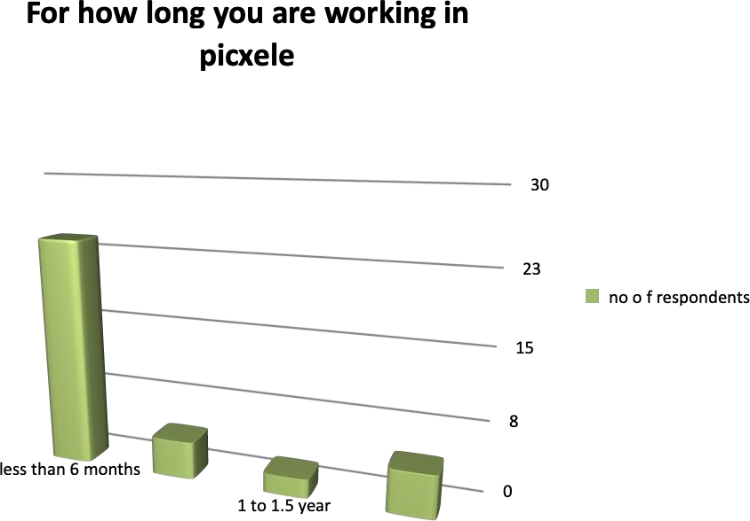

Interpretation

From table 1 and figure 1, we can conclude that majority of people worked in Jain Bandhu for less than 6 months.

How is your working experience?
Table 2

S.NO | OPTIONS | RESPNDENT | PERCENTATGE
1 | Very good | 18 | 58%
2 | Good | 10 | 32.3%
3 | Neutral | 3 | 9.7%
4 | Bad | 0 | 0%
5 | Very bad | 0 | 0%
 | Total | 31 | 100%

Interpretation

From table 2, we can conclude that The results reveal that employees generally have favorable experiences in the organization, indicating a positive work environment and effective management practices. Similar findings have been reported in previous studies, which emphasize the importance of workplace culture in enhancing employee satisfaction.

Do you feel team spirit in the organization?
Table 3

S.NO | OPTIONS | RESPONDENTS | PERCENTAGE
1 | Very good | 14 | 45.2%
2 | Good | 13 | 41.9%
3 | Neutral | 4 | 12.9%
4 | Bad | 0 | 0
5 | Worst | 0 | 0
 | Total | 31 | 100%

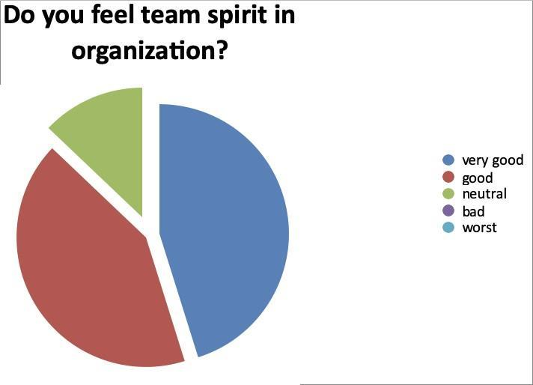

Interpretation

From the figure 3 and table 3, we can conclude that The high level of team spirit observed among employees indicates the existence of collaborative work culture, which positively contributes to employee morale and organizational effectiveness.

Does your supervisor listen to your opinions and suggestion?

S.NO | OPTIONS | RESPONDENTS | PERCENTAGE
1 | Yes | 31 | 100%
2 | No | 0 | 0
 | Total | 31 | 100%

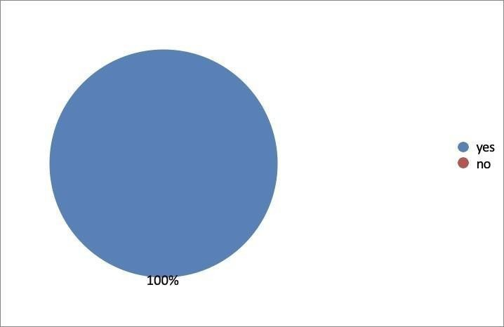

Interpretation

From table 4 and figure 4, we can conclude that Employees perceive that supervisors are receptive to their opinions and suggestions, which reflects effective communication and participative management practices within the organization.

Rate your satisfaction level towards trainers and supervisors of the organization?

S.NO | OPTIONS | RESPONDENTS | PERCENTAGE
1 | Highly dissatisfied | 0 | 0%
2 | Dissatisfied | 1 | 3.2%
3 | Neutral | 3 | 6.5%
4 | Satisfied | 10 | 32.3%
5 | Highly satisfied | 18 | 58.1%
 | Total | 31 | 100%

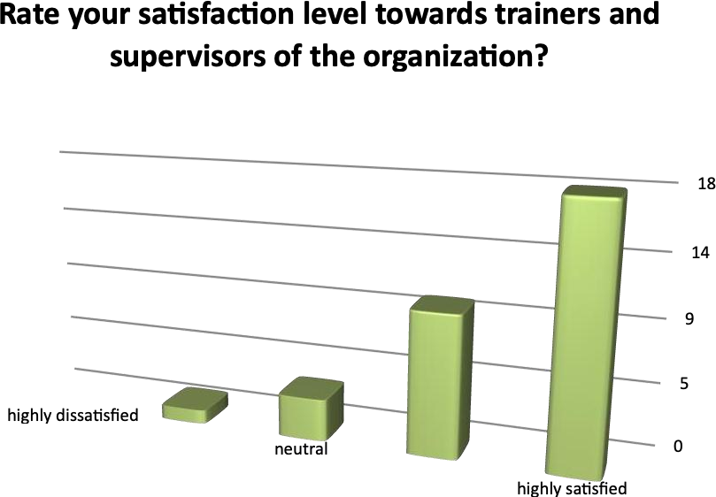

Interpretation

From the figure 5 and table 5, we can easily say that Satisfaction with supervisors indicates the presence of supportive leadership, which is recognized as an important factor influencing employee motivation and organizational commitment.

Do you feel proud to be associated with the company?

S.NO | OPTIONS | RESPONDENTS | PERCENTAGE
1 | Yes | 29 | 93.5%
2 | No | 2 | 6.5%
 | Total | 31 | 100%

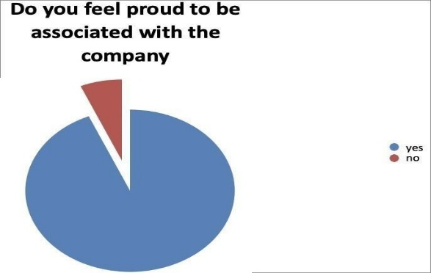

Interpretation

It proves that the employees of the organization feel proud to be the part of the organization.

Do you get regular feedback from you’re your superior regarding your performance?

S.NO | OPTIONS | RESPONDENTS | PERCENTAGE
1 | Yes | 29 | 93.5%
2 | No | 2 | 6.5%
 | Total | 31 | 100%

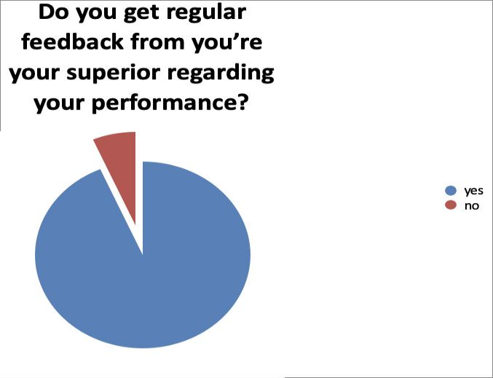

Interpretation
From the above table and figure, we can easily understand that the employees get regular feedback on daily basis from their superiors.

Are you satisfied with the level of trust the manager shows towards the team?

S.NO | OPTIONS | RESPONDENTS | PERCENTAGE
1 | Highly satisfied | 16 | 45.2%
2 | Satisfied | 14 | 51.6%
3 | Neutral | 1 | 3.2%
4 | Dissatisfied | 0 | 0
5 | Highly dissatisfied | 0 | 0
 | Total | 31 | 100%

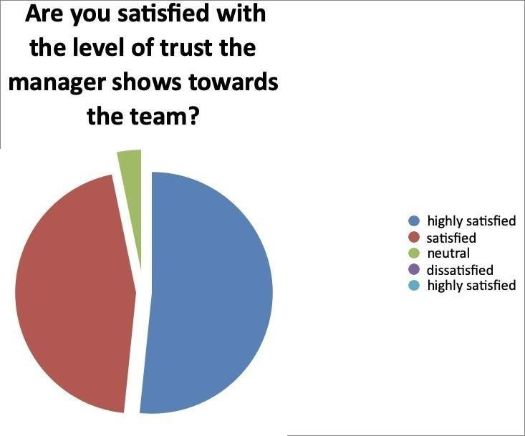

Interpretation

From the above given table and figure, it is proved that the Mutual trust between managers and employees contributes to a positive organizational climate and enhances cooperation and job satisfaction among employees.

Does your superior cares about you as a person?

S.NO | OPTIONS | RESPONDENTS | PERCENTAGE
1 | Yes | 29 | 93.5%
2 | No | 2 | 6.5%
 | Total | 31 | 100%

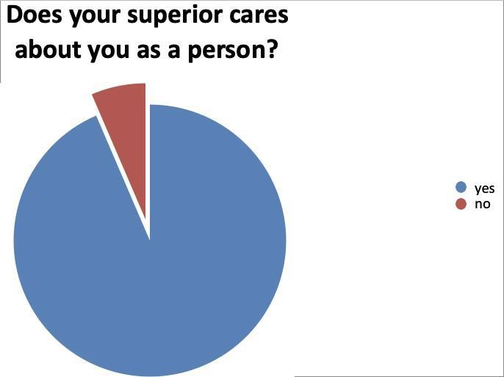

Interpretation

From the above table and figure. We can definitely say that the superior cares about the employees as person.

Do you find your job role interesting and challenging?

Table 5

S.NO | OPTIONS | RESPONDENTS | PERCENTAGE
1 | Yes | 27 | 87.1%
2 | No | 4 | 12.9%
 | Total | 31 | 100%

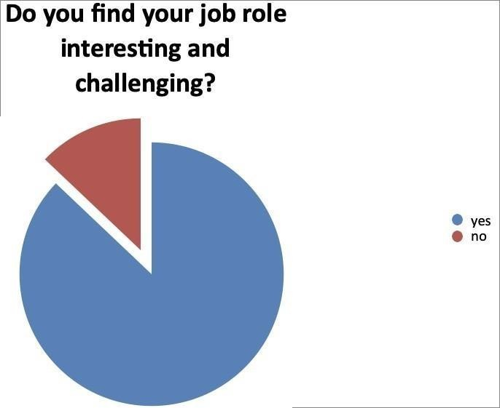

Interpretation

From the above given table and figure, we can easily say that majority of people finds it interesting and challenging.

CONCLUSION

The study concludes that employees of Jain Bandhu are generally satisfied with their work environment, team spirit, supervisory support, feedback mechanisms, and organizational culture. Most respondents expressed positive perceptions regarding communication, trust, and job challenges, which contribute to employee motivation and commitment. Maintaining supportive leadership practices, encouraging employee participation, and providing opportunities for professional development may further enhance employee satisfaction and organizational effectiveness.

REFERENCES

- Maslow, A. H. A Theory of Human Motivation. Psychol. Rev. 1943, 50 (4), 370–396. https://doi.org/10.1037/h0054346.
- Herzberg, F.; Mausner, B.; Snyderman, B. B. The Motivation to Work, 2nd ed.; John Wiley & Sons: New York, 1959.
- Locke, E. A. The Nature and Causes of Job Satisfaction. In Handbook of Industrial and Organizational Psychology; Dunnette, M. D., Ed.; Rand McNally: Chicago, IL, 1976; pp 1297–1349.
- Hackman, J. R.; Oldham, G. R. Development of the Job Diagnostic Survey. J. Appl. Psychol. 1975, 60 (2), 159–170. https://doi.org/10.1037/h0076546.
- Meyer, J. P.; Allen, N. J. A Three-Component Conceptualization of Organizational Commitment. Hum. Resour. Manage. Rev. 1991, 1 (1), 61–89. https://doi.org/10.1016/1053-4822(91)90011-Z.
- Judge, T. A.; Thoresen, C. J.; Bono, J. E.; Patton, G. K. The Job Satisfaction–Job Performance Relationship: A Qualitative and Quantitative Review. Psychol. Bull. 2001, 127 (3), 376–407. https://doi.org/10.1037/0033-2909.127.3.376.
- Spector, P. E. Measurement of Human Service Staff Satisfaction: Development of the Job Satisfaction Survey. Am. J. Community Psychol. 1985, 13 (6), 693–713. https://doi.org/10.1007/BF00929796.
- Robbins, S. P.; Judge, T. A. Organizational Behavior, 18th ed.; Pearson Education: New York, 2019.
- Alshitri, K. I. Employee Satisfaction in Higher Education: The Case of Saudi Arabia. Manag. Sci. Lett. 2013, 3 (6), 1655–1660. https://doi.org/10.5267/j.msl.2013.05.036.
- Bakotić, D. Relationship between Job Satisfaction and Organisational Performance. Econ. Res.-Ekon. Istraž. 2016, 29 (1), 118–130. https://doi.org/10.1080/1331677X.2016.1163946

